Human–Computer Interaction (HCI) – CSC 436
Human–Computer Interaction (HCI) is a multidisciplinary field of study that focuses on the design, evaluation, and implementation of interactive computing systems for human use, as well as the analysis of the interactions between humans and these systems.
In simpler terms, HCI examines how people interact with computers and how to design technology that is efficient, effective, and user-friendly. It draws knowledge from computer science, cognitive psychology, design, and ergonomics to ensure that systems are both technically functional and tailored to human needs and limitations.
At the undergraduate level, HCI emphasizes:
- User interface design (e.g., layout, usability, and accessibility)
- User experience (UX) principles
- Interaction techniques and input devices
- Prototyping and usability testing
- Cognitive models of user behavior
In essence, HCI seeks to bridge the gap between human capabilities and computer technologies, enabling intuitive, efficient, and enjoyable user experiences.

Foundations of Human Computer Interaction (HCI)

1. Introduction
Human–Computer Interaction (HCI) is the scientific and design discipline that studies how people interact with computers and how to design systems that enable people to interact effectively, efficiently, and enjoyably.
At its core, HCI lies at the intersection of Computer Science, Cognitive Psychology, and Design, focusing on creating interactive systems that amplify human capabilities rather than hinder them.
The foundation of HCI rests upon a key question:
How can we make computing technology more usable, accessible, and responsive to human needs?

2. Definition of Human–Computer Interaction
According to the ACM SIGCHI (Special Interest Group on Computer–Human Interaction):
HCI is a discipline concerned with the design, evaluation, and implementation of interactive computing systems for human use and with the study of major phenomena surrounding them.
Simply put, HCI studies the interaction between humans (users) and computers (machines) in order to make technology more intuitive, efficient, and user-centered.

3. The Goals of HCI
The ultimate goals of HCI are:
- Usability: Ensuring systems are easy to learn and use.
- Effectiveness: Enabling users to accomplish tasks accurately and completely.
- Efficiency: Allowing tasks to be performed with minimal time and effort.
- Safety: Minimizing user errors and potential harm.
- Satisfaction: Ensuring positive user experience and enjoyment.
- Accessibility: Designing for users of all abilities and backgrounds.

4. Historical Evolution of HCI
The roots of HCI can be traced back to the 1950s and 1960s, during the emergence of computing technology:
- 1950s–1960s: Interaction was primarily through punch cards and command-line interfaces.
- 1970s–1980s: Introduction of Graphical User Interfaces (GUI) by Xerox PARC and later popularized by Apple.
- 1990s: Rise of World Wide Web and multimedia interfaces.
- 2000s–Present: Emergence of mobile, ubiquitous, wearable, and voice-based computing.
Today, HCI encompasses emerging areas like Virtual Reality (VR), Augmented Reality (AR), Artificial Intelligence (AI), and Affective Computing—creating more natural and intelligent interaction models.

5. Core Disciplines That Shape HCI
HCI is inherently multidisciplinary, drawing concepts from several fields:
Discipline | Contribution to HCI
Computer Science | Algorithms, software design, interface development
Cognitive Psychology | Understanding human perception, memory, and attention
Design (Industrial & Graphic) | Visual aesthetics, usability, ergonomics
Linguistics | Natural language interaction and dialogue systems
Sociology/Anthropology | Understanding user contexts, collaboration, and culture
Ergonomics | Physical interaction and comfort in hardware design

6. The Human Component in HCI
Understanding human behavior and capabilities is central to HCI design.
This involves:
- Perception: How users interpret visual, auditory, and tactile cues.
- Cognition: How users process information and make decisions.
- Memory: How users recall commands, icons, and navigation paths.
- Emotion: How design influences user satisfaction and motivation.
HCI designers must adapt systems to human limitations rather than forcing users to adapt to machines.

7. The Computer Component in HCI
The computer represents the hardware and software with which humans interact:
- Input devices: Keyboard, mouse, touchscreens, voice, gesture sensors.
- Output devices: Monitors, speakers, haptic feedback, AR/VR headsets.
- Interaction styles: Command-line, GUI, direct manipulation, conversational interfaces, and immersive systems.
Designing the right interaction medium enhances efficiency and accessibility.

8. The Interaction Process
The interaction process can be modeled as a loop:
- User formulates a goal.
- User performs an action through an interface.
- System responds and provides feedback.
- User interprets feedback and decides the next step.
This feedback cycle (Norman’s Execution–Evaluation model) ensures that users maintain control and understanding throughout interaction.

9. Principles of Good Interface Design
According to Jakob Nielsen’s usability heuristics and Don Norman’s design principles, effective interfaces should:
- Provide visibility of system status.
- Match real-world metaphors (intuitive design).
- Offer user control and freedom (undo, redo).
- Maintain consistency and standards.
- Prevent errors and provide clear recovery options.
- Support recognition over recall.
- Offer flexibility and efficiency for expert users.
- Provide aesthetic and minimalist design.
- Offer help and documentation when needed.

10. Emerging Trends in HCI
The field continues to evolve rapidly, shaped by technological innovations:
- Artificial Intelligence (AI) and Adaptive Interfaces
- Brain–Computer Interfaces (BCI)
- Multimodal Interaction (voice, gesture, eye-tracking)
- Ubiquitous and Wearable Computing
- Augmented and Virtual Reality (AR/VR)
- Affective Computing (systems that detect emotion)
- Sustainable and Inclusive Design (ethical HCI)
These developments move HCI towards human-centered intelligent environments that learn from and adapt to users.

11. Relevance of HCI in Computer Science
In modern computing education and practice, HCI plays a pivotal role in:
- Software Engineering: Enhancing usability and system acceptance.
- Artificial Intelligence: Improving explainability and trust in intelligent systems.
- Data Science: Designing interactive visualizations.
- Cybersecurity: Designing user-friendly authentication systems.
- Education Technology: Developing effective learning interfaces.
- Healthcare and Accessibility: Creating assistive technologies for diverse populations.

12. Conclusion
The foundation of Human–Computer Interaction is the harmonization of human needs with technological possibilities. It emphasizes that technology should not merely function—it should delight, empower, and adapt to its users.
As computing continues to evolve into every domain of life, the essence of HCI remains:
“Designing technology that understands humans as much as humans understand technology.”

Recommended Readings
- Dix, A., Finlay, J., Abowd, G., & Beale, R. (2004). Human–Computer Interaction (3rd ed.). Pearson.
- Preece, J., Rogers, Y., & Sharp, H. (2019). Interaction Design: Beyond Human–Computer Interaction (5th ed.). Wiley.
- Norman, D. A. (2013). The Design of Everyday Things. Basic Books.
- Shneiderman, B., Plaisant, C., Cohen, M., Jacobs, S., & Elmqvist, N. (2016). Designing the User Interface: Strategies for Effective Human–Computer Interaction. Pearson.

What HCI Is and Why It Is Important
Human–computer interaction (HCI) is a cross-disciplinary area (such as,
engineering, psychology, ergonomics, design) that deals with the theory,
design, implementation, and evaluation of the ways that humans use and
interact with computing devices. Interaction is a concept to be distinguished from another similar term, interface. Roughly speaking, interaction refers to an abstract model by which humans interact with the computing device for a given task, and an interface is a choice of technical realization (hardware or software) of such a given interaction model. Thus, the letter I in HCI refers to both interaction and interface, encompassing the abstract model and the technological methodology as shown in Figure 1.1.
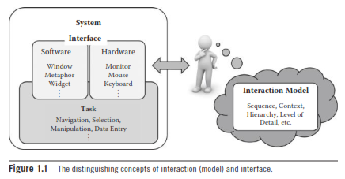
HCI has become much more important in recent years as computers (and embedded devices) have become commonplace in almost all facets of our lives. Aside from merely making the necessary computational functionalities available, the early focus of HCI has been in how to design interaction and implement interfaces for high usability.
The term high usability means that the resulting interfaces are easy to use, efficient for the task, ensure safety, and lead to a correct completion of the task. Usable and efficient interaction with the computing device in turn translates to higher productivity.
The simple beautiful appeal of interfaces (while satisfying the need for usability) is now a critical added requirement for commercial success as well. The family of distinctly designed Apple® products is a good example. Apple products are attractive and have created a multitude of faithful followers even though their functionality may be virtually equal to their competitors. In this context, the concept of user experience (UX) has lately become a buzzword, a notion that not only encompasses the functional completeness, high usability, and attractive appeal of the interactive artifact, but also its seamless integration into one’s lifestyle or even creating a new one around it. See Figure 1.2.
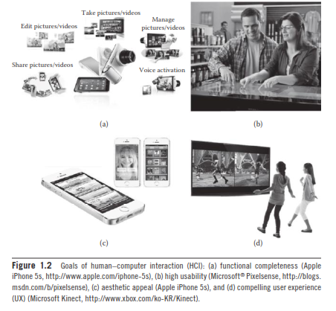
A less acknowledged fact is how HCI has had a huge impact in the history of computing and changed our daily lives. It was probably the invention (or rediscovery) of the mouse that was the root in the personal computer revolution, making the operation of a computer intuitive and much easier than the previous system of keyboard commands. The spreadsheet interface made business computing a huge success. The Internet phenomenon could not have happened without the web-browser interface.
Smartphones, with their touch-oriented interfaces, have nearly replaced the previous generation of feature phones. Body-based and action-oriented interfaces are now introducing new ways to play and enjoy computergames.
HCI still continues to redefine how we view, absorb, exchange, create, and manipulate information to our advantage as shown in Figure 1.3.
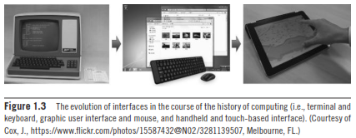

Principles of HCI
Despite its importance, good HCI design is generally difficult, mainly because it is a multiobjective task that involves simultaneous consideration of many things, such as the types of users, characteristics of the tasks, capabilities and cost of the devices, lack of objective or exact quantitative evaluation measures, and changing technologies, to name just a few. A considerable knowledge in many different fields is required. Over the relatively young history of HCI, researchers and developers in the field have accumulated and established basic principles for good HCI design in hopes of achieving some of the main objectives (as a whole) that were laid out in the previous section. These HCI principles are general, fundamental, and commonsensical, applicable to almost any HCI design situation. Here, we provide a short review of the main HCI principles.

- Know Thy User
The foremost creed in HCI is to devise interaction and interfaces around the target users. This overall concept was well captured by the phrase, “Know thy user,” coined by Hansen in 1971, even though the so-called user-centered design approach has become a buzzword only in recent years. This principle simply states that the interaction and interface should cater to the needs and capabilities of the target user of the system in design. However, as easy as this sounds, it is more often the case that the HCI designers and implementers proceed without a full understanding of the user, for example, by just guessing and pretending to know and be able to predict how the representative user might respond to one’s design. Ideally, comprehensive information (such as, age, gender, education level, social status, computing experience, cultural background) about the representative target user should be collected and analyzed to determine their probable preferences, tendencies, capabilities (physical and mental), and skill levels. Such information can be used to properly model interaction and pick the right interface solution for the target users.
Consider a situation where a developer is working to change an interface, supposedly to achieve higher usability. However, we might need to remember that while young adults are extremely adept at and open to adopting new interfaces, older generations are much less so. Here is another example. Males are generally known to be better than females in terms of spatial ability and, as such, one might consider such a fact in employing three-dimensional (3-D) user interfaces. However, other studies point to females majoring in engineering and science to possess an equivalent level of spatial ability as their male counterparts. So sometimes, conventional wisdom alone may not be sufficient to warrant proper interface design. These examples illustrate that there are a great many aspects that need to be considered in this regard. If a direct field study is not feasible, an experienced and humble HCI designer will at least try to leverage the vast knowledge available from cognitive psychology, ergonomics, and anthropomorphic data to assess the capabilities and characteristics of the target user group.
Figure 1.4 shows examples of user-centered designs of web pages for kids and the elderly.
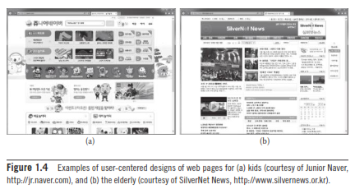
A related (or perhaps even opposing) notion to the user-centered design is the concept of “universal usability,” which roughly promotes “humane” interfaces that cater to a wide (rather than a specific) range of users, i.e., across age groups, skill levels, cultural backgrounds, and disability levels. Such a notion has become almost required in our advanced multicultural societies. However, as wonderful as it sounds, it is generally very difficult to achieve this with a single interface.
Usually, universal usability is achieved by justifying the investment required to build separate interfaces for distinct user groups. For example, in advanced countries, many government web pages are now legally required to provide interfaces in different languages and for color-blind and visually challenged users as shown in Figure 1.5. Many inter-active systems provide both menu-driven commands for novices and keyboard-based hot keys for experts. See Figure 1.6.
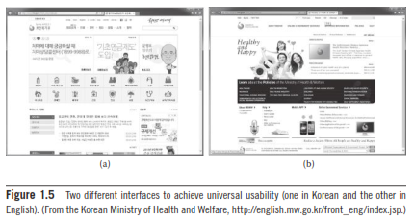

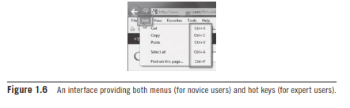

- Understand the Task

Another almost-commonsensical principle is to base HCI design on the understanding of the task. The term task refers to the job to be accomplished by the user through the use of the interactive system. In fact, understanding the task at hand is closely related to the interaction modeling and user analysis. It really boils down to identifying the sequence and structure of subtasks at an abstraction level appropriate for the typical user within the larger application context. Take the subtask (for a larger application) for “changing the Wi-Fi connection access point” for a smartphone. For an expert user experienced in computer networks, the task might be modeled with detailed steps, asking the user to select from a pool of available nearby access points based on their characteristics such as the signal strength, bandwidth, security level, and so forth. On the other hand, for a casual user, the subtask might only involve entering a password for the automatically selected access point. See Figure 1.7.
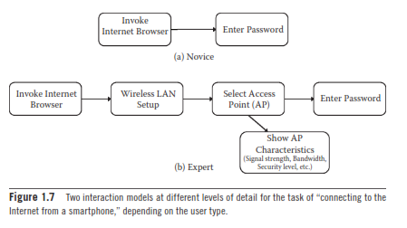

Note again that the task (or, equivalently, the interaction) model must ideally come from the user. Different users will have different mental models of the task at hand, and this must be reflected in the structure of the interface to simplify implementation for all users.
However, it is not always the case that modeling interaction after the user is the most efficient approach. One must remember that humans are very adaptive and, as such, a nonuser-based task/interaction model may sometimes be developed based solely on the general human capacity.

- Reduce Memory Load

Designing interaction with as little memory load as possible is a principle that also has a theoretical basis. Humans are certainly more efficient in carrying out tasks that require less memory burden, long or short term. Keeping the user’s short-term memory load light is of particular importance with regard to the interface’s role as a quick and easy guidance to the completion of the task. The capacity of the human’s short-term memory (STM) is about 5–9 chunks of information (or items meaningful with respect to the task), famously known as the “magic number”. Light memory burden also leads to less erroneous behavior. This fact is well applied to interface design, for instance, in keeping the number of menu items or depth to less than this amount to maintain good user awareness of the ongoing task or in providing reminders and status information continuously throughout the interaction as shown in Figure 1.8.
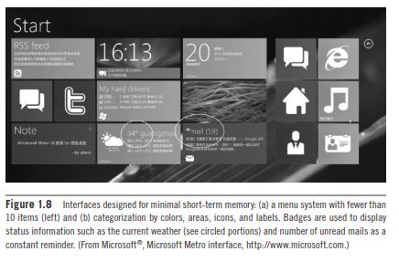

- Strive for Consistency
In the longer term, one way to unburden the memory load is to keep consistency. This applies to (a) both within an application and across different applications and (b) both the interaction model and interface implementation. For instance, the user is likely to get confused and exhibit erroneous responses if the same subtask is involved, at different times, for different interaction steps or interface methods. Note that the exact same subtasks may appear across different applications as well. Aside from being able to remember what to do, consistency and familiarity also lead to higher acceptability and preference. One way the Microsoft Windows®–based applications maintain their competitiveness is by promoting consistent and familiar interfaces as shown in Figure 1.9.

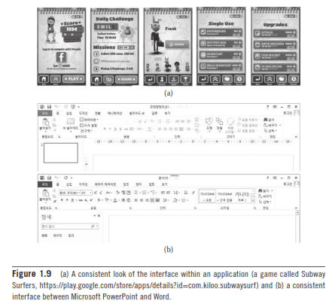

- Remind Users and Refresh Their Memory
Any significant task will involve the use of memory, so another good strategy is to employ interfaces that give continuous reminders of important information and thereby refresh the user’s memory. The human memory dissipates information quite quickly, and this is especially true when switching tasks in multitasking situations (which is a very prevalent form of interaction these days). In fact, research shows that our brain internally rehearses information encoding during multitasking. Even a single task may proceed in different contextual spans. For instance, in an online shopping application, one might cycle through the entry of different types of information: item selection, delivery options, address, credit card number, number of items, etc. To maintain the user’s awareness of the situation and further elicit correct responses, informative, momentary, or continuous feedback will refresh the user’s memory and help the user complete the task easily.
One particular type of informative feedback (aside from the current status) is the reaffirmation of the user action to signal the closureof a larger process. An example might be not only explicitly confirming the safe receipt of a credit card number, but also signaling that the book order is complete (and “closed”). Such a closure will bring satisfaction by matching the user’s mental picture of the ongoing interactive process as shown in Figure 1.10.
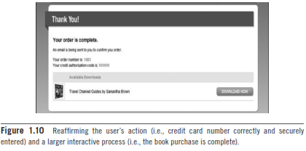

- Prevent Errors/Reversal of Action

While supporting a quick completion of the task is important, error-free operation is equally important. As such, the interaction and interface should be designed to avoid confusion and mental overload.
Naturally, all of the aforementioned principles apply here. In addition, one effective technique is to present or solicit only the relevant information/action as required at a given time. Inactive menu items are good examples of such a technique. Also, having the system require the user to choose from possibilities (e.g., menu system) is generally a safer approach than to rely on recall (e.g., direct text input) as shown in Figure 1.11.
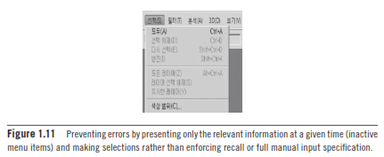
Despite employing some of the principles and techniques described here, there is always a chance that the user will make mistakes. Thus, a very obvious but easy-to-forget feature is to allow an easy reversal of action. This puts the user into a comfortable state and increases user satisfaction as well as depicted in Figure 1.12.
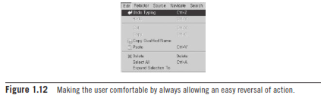

- Naturalness
The final major HCI principle is to favor “natural” interaction and interfaces. Naturalness refers to a trait that is reflective of various operations in our everyday life. For instance, a perfect HCI may one day be realized when a natural language–based conversational interface is possible, because this is the prevalent way that humans communicate. However, it can be tricky to directly translate real-life styles and modes of interaction to and for interaction with a computer. Perhaps a better approach is to model interaction “metaphorically” to the real-life counterpart, extracting the conceptual and abstract essence of the task. For instance, Figure 1.13 shows an interface called the ARCBall for rotating an object in 3-D space using a mouse (2-D device). In order to rotate, the selected object is overlaid with and enclosed by a transparent sphere, and the user drags on the surface of the sphere to rotate the object inside. One might consider this rotation technique to be metaphoric because it abstracts the interaction object into the shape of a sphere, the most rotational object we know.
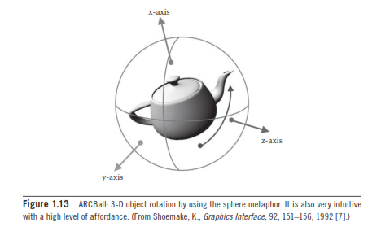
A natural or metaphoric interface (assuming that the metaphor is not contrived) will also have affordance, a property (or additional cues) that appeals to our innate perception and cognition, thus making it so intuitive the example of the ARCBall, the spherical shape of the rotator GUI may be regarded to exhibit a high level of affordance, requiring no explanation as to how to rotate the object.

